***Animals***

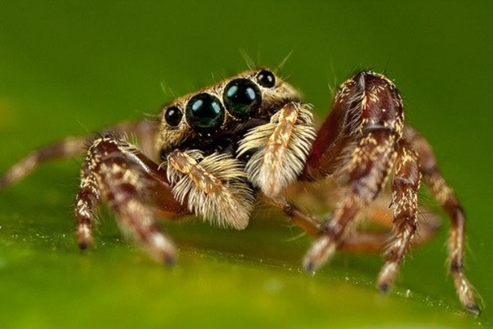Spiders have eight legs

but they have no necks.

Their webs are sticky as glue

Even scientists have no clue.

Some are poisonous, some are not

Some are big, some are as small as a spot.

They are friendly

But people think they‘re deadly.

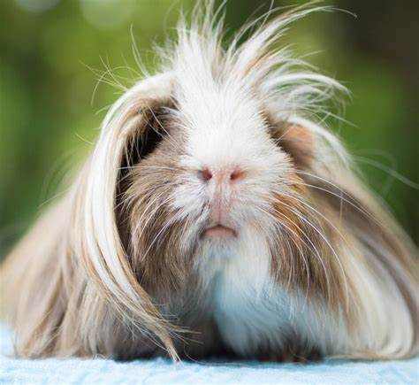Let’s talk about guinea pigs

which are not made for tricks.

Guinea pigs are really sweet,

they also hate to eat meat

Instead they really like fresh grass

But at home they live in cages made of glass.

They‘d like to eat tomatoes

But they can’t eat potatoes.

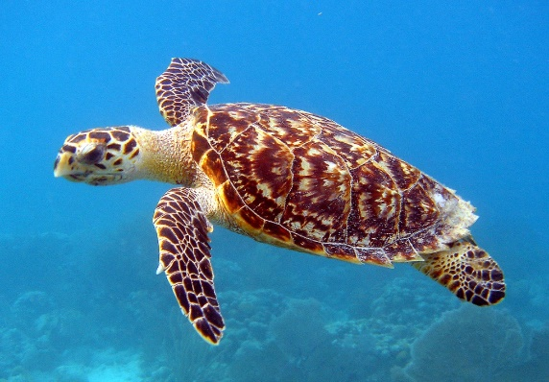This is a turtle - it goes very slow  
it carries its house, wherever it goes:  
It puts its head out, when it wants to eat  
and pulls it back, when it wants to sleep.   
You can find the turtle all over the sea  
I hope the turtle is happy and free!

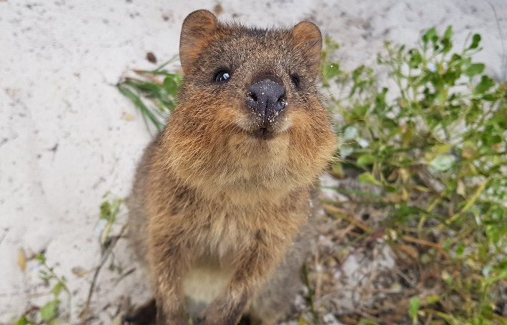The kangaroo’s cousin, cute little quokka  
with teddybear eyes and a winning small smile,   
escape the fox – be safe at last.  
My friend, the little quokka.

Written by Laszlo, Elmira, Mona and Elena