***Our Poetry defeat***

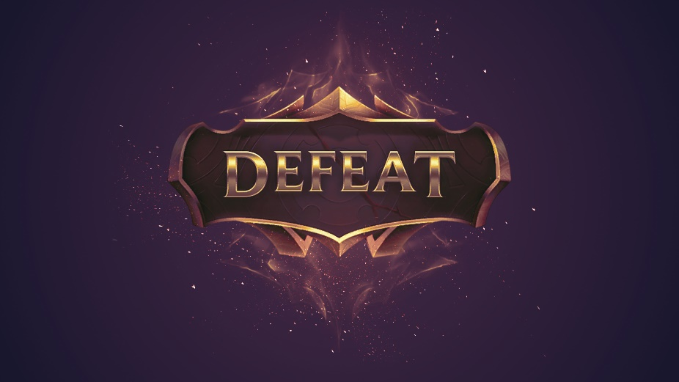You wake up  
and log into league   
only to see  
**defeat**

You want to play again  
but your cat  
eats your feet  
= **defeat**

You’re close to a win   
but a bee stings your chin  
= **defeat**

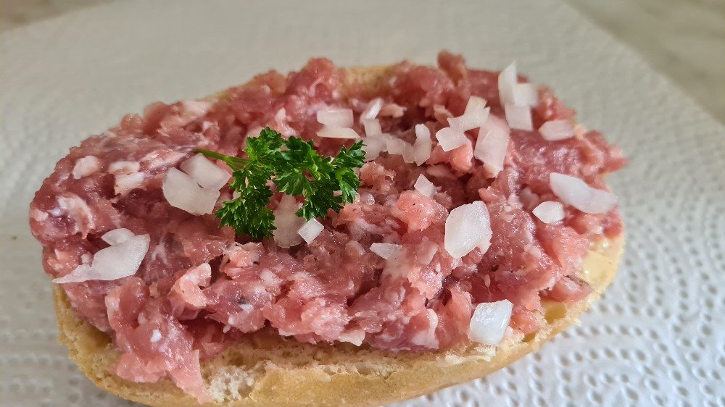You want to get something to eat  
but all you find  
is meat  
= **defeat**

You go to the store to get a good treat  
but all you find  
is more meat  
= **defeat**

You have enough, you go to sleep  
but in your nightmares  
all you see is  
**defeat**

Written by:

Chepper, Topper, Jchaklen