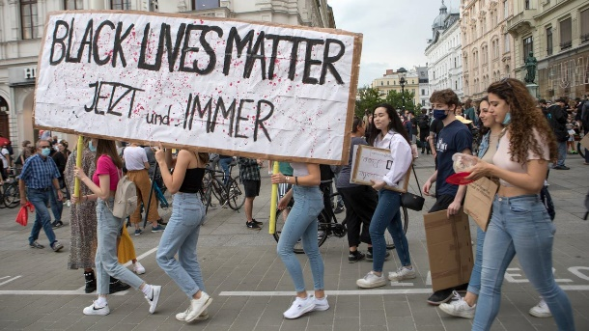**racism**

Some people are black some people are white

Everybody should have the same rights

Nelson Mandela was a great man

He had to go into prison because of fighting against racism

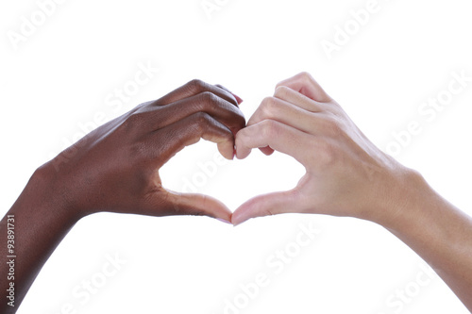Black people go in prison for no reason

But everybody can get „brown“ in summer season.

Black people don’t have many rights

That is causing uncountable fights

Here in Austria everybody has a roof

In Africa they don’t - it’s not a joke

But it’s the sad truth

There are many people like you and me

together we can make a better society.

Laura, Magdalena, Xulrich, Löthe